**Enlightenment: Locke & Montesquieu**

***Part 1****. Match the key terms found in the word bank below to the definitions that best describe them. Type the vocabulary word into the matching empty box. Each term will only be used once.*

|  |  |  |
| --- | --- | --- |
| Enlightenment | Natural Law | Social Contract |
| Separation of Powers | John Locke | Montesquieu |
|  |  |  |
| **Key Term** | **Definition** | | |
|  | 1) The division of powers into three branches, or parts, of government. | | |
|  | 2) The concept that all human beings have basic rights, like life, liberty, and property. | | |
|  | 3) An agreement among the people to set up a government and obey its laws. | | |
|  | 4) Enlightenment philosopher who developed the idea of separation of powers | | |
|  | 5) Period in history characterized by dramatic revolutions in science, philosophy, society, and politics. | | |
|  | 6) Enlightenment philosopher who developed the ideas of natural law and the social contract. | | |

***Part 2****. Read each of the following quotes and decide which philosopher would likely have said it. Type “L” for Locke and “M” for Montesquieu.*

|  |  |
| --- | --- |
| **Quote** | **Locke or Montesquieu?** |
| 7) We need a constitution in order to protect our rights. |  |
| 8) Our government should have a legislative, executive, and judicial branch. |  |
| 9) If one part of government has too much power, it can lead to tyranny, or corrupt rule. |  |
| 10) All men are created equal with certain rights that cannot be taken away. |  |
| 11) Each part of government should have the ability to check, or limit, the power of the other parts. |  |
| 12) If the government tries to take our rights away instead of protecting them, we have the right to change or replace that government. |  |

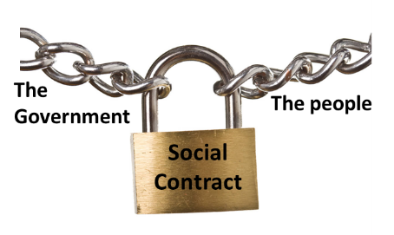***Part 3****. Based on our lesson, answer the following questions.*

13) The statements below are from the 1776 Virginia Declaration of Rights. Which one best reflects the Enlightenment ideas of government as expressed by Montesquieu?

A) That in all criminal prosecutions a man has the right to demand a speedy trial by an impartial jury.

B) That the legislative, executive, and judicial branches shall be separate and distinct.

C) That the freedom of the press is one of the great elements of liberty and can never be limited.

D) That a militia, composed of the body of the people … is the proper and safe defense of the state.

ANSWER:

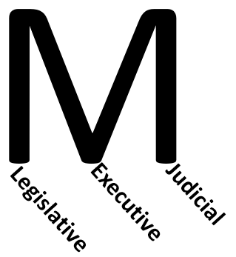14) Congress passes a law about taxes, and the IRS (a department of the executive branch that serves under the President’s control) makes sure that people follow that law. What is this an example of?

A) John Locke’s natural law

B) Montesquieu’s Enlightenment

C) John Locke’s social contract

D) Montesquieu’s separation of powers

ANSWER:

15) The Declaration of Independence contains a passage which states that all men have the “unalienable rights” of “life, liberty, and the pursuit of happiness.” What is this an example of

A) John Locke’s natural law

B) Montesquieu’s Enlightenment

C) John Locke’s social contract

D) Montesquieu’s separation of powers

ANSWER: